# DWA_02.8 Knowledge Check_DWA2

______________________________________________________________________________________

1. What do ES5, ES6 and ES2015 mean - and what are the differences between them?

ES is short for ECMAScript which means that ES5 and ES6 ( ES2015 is ES6 ) are just updates to ECMAScript produced by ECMA (European Computer Manufacturers Association).

The main differences between ES5 and ES6 are that ES6 has ‘ let and const ‘, ’ for…of loops’, and ‘arrow functions whilst ES5 does not, however, even though ES5 is also slower than ES6 it still has more browser support than ES6 since most browsers implement ECMAScript updates in

__________________________________________________________________________________

2. What are JScript, ActionScript and ECMAScript - and how do they relate to JavaScript?

JScript- was created by Microsoft to support their browser Internet Explorer and is basically the reverse engineering of JavaScript (meaning they are identical except for some differences like conditional compilations which are conditional statements that were used to provide and hide code to and from versions of Internet Explorer.

ActionScript - is a copycat of JavaScrip made by Macromedia that is used in games and websites.

ECMAScript - after the JavaScript specification by the ECMA microsoft and Netspace combined Jscript and Javascript to make EMCAScript.

What they all have in common is that they make websites interactive and stop them from being static.

_____________________________________________________________________________________

3. What is an example of a JavaScript specification - and where can you find it?

An example of a JavaScript specification is the Math.floor (x) operator where at page 21.3.2.16 on the ECMA-262 , 12th edition, June 2021 it states how the operator will evaluate values (if value is a whole number don’t change if a decimal number round down).

____________________________________________________________________________________

4. What are v8, SpiderMonkey, Chakra and Tamarin? Do they run JavaScript differently?

v8, SpiderMonkey, Chakra and Tamarin are JavaScript compilers that change JavaScript source code into binaries (ones and zeros) which are used by the computer.

History of the 4 compilers:

-V8: is a free open source JavaScript and web assembly engine made by Chromium projects and used to support Chromium and google web browsers.

-SpiderMonkey: is a free open source JavaScript and web assembly engine made by Mozzila foundation.

- Chakra: is a non-free source JScript engine and web assembly engine made by Microsoft used in Internet Explorer web.

- Tamarin : is a discontinued free software virtual machine ( which is an emulation of a computer ) with Just-In-Time compiler developed by Adobe which was supposed to be used in ES4, however, ES4 was never made.

Differences of the compilers:

All of these compilers do the same thing meaning they don't run JavaScript differently, however, they are made by different companies for different browsers , and they also have their own set of features , optimizations and performance characteristics.

_____________________________________________________________________________________

5. Show a practical example using [**caniuse.com**](http://caniuse.com/) and the MDN compatibility table.

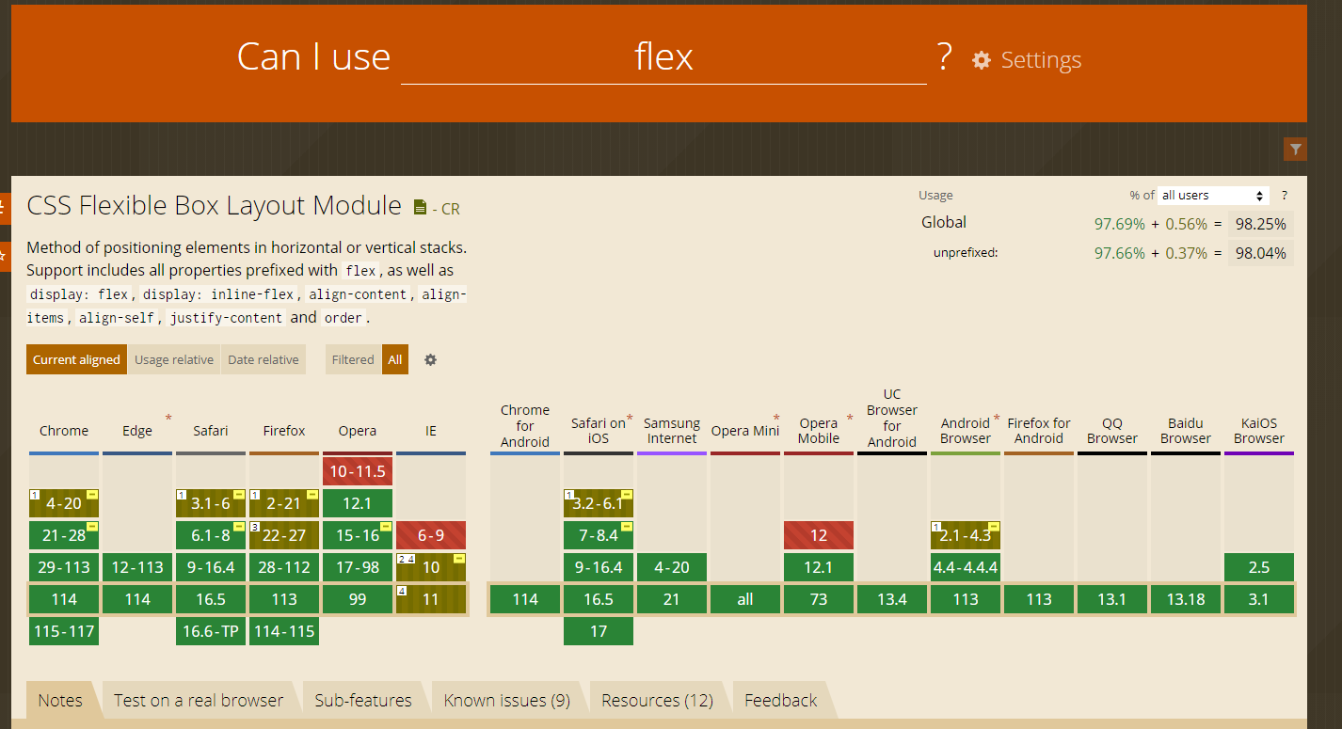

Method of positioning elements in horizonta or vertical stack.it comes with other different properties.

____________________________________________________________________________________